Verify eMMC Presence command
dmesg | grep mmc
df –h
cat /sys/class/mmc_host/mmc0/mmc0\:0001/life_time
Expected response
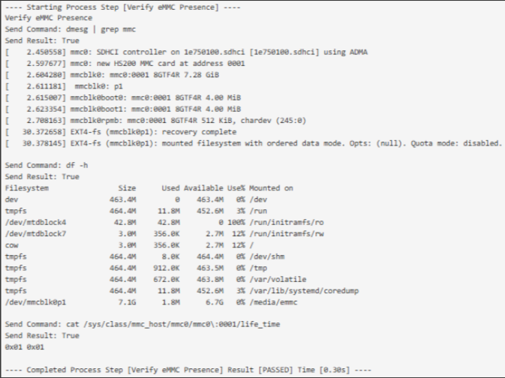

1139708-03
AAHIVT253702535
04006EE2F48C
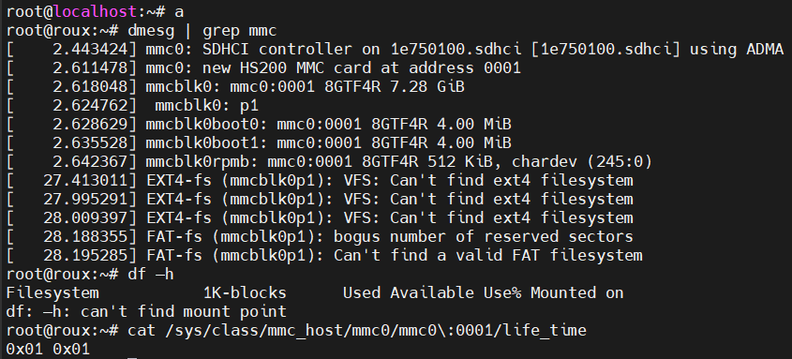

1139708-03
AAHIVT253600995
04006EE2A464
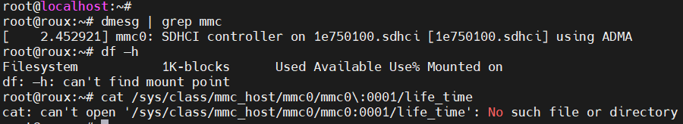

1139708-03
AAHIVT253600341
04006EE29A2C
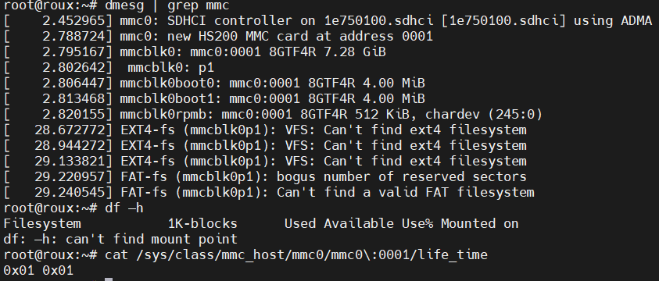

1139708-03
AAHIVT253700711
04006EE2D80C
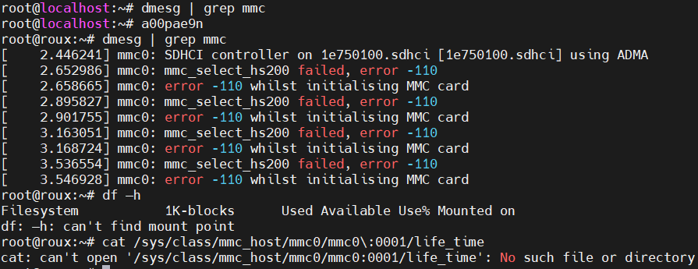

1119041-07
AAHFWI253901225
04006EF7D714
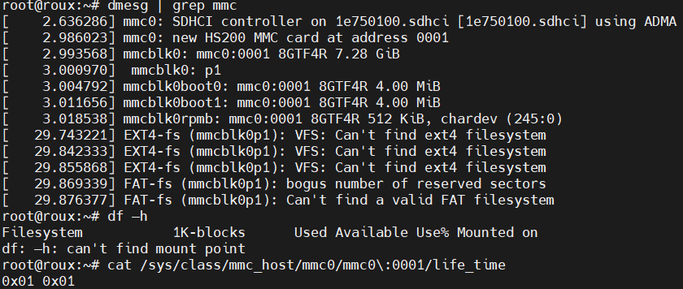

1119041-07
AAHFWI253901642
04006EF7DE08
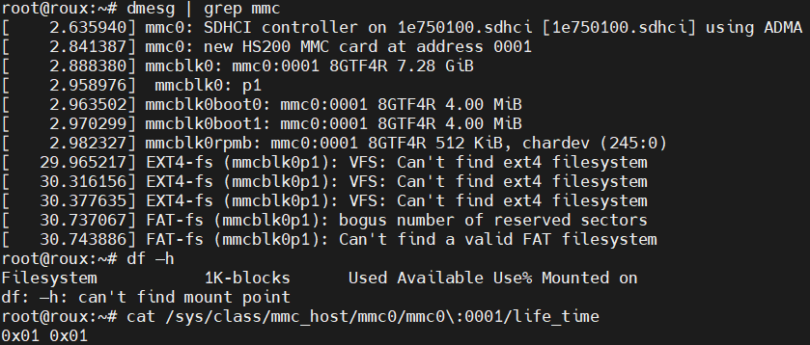

Golden unit
